**Design components and material selection**

Cover

A design of the cover was handed over by the previous group but it was not ideal in regards to its appearance and suitability for its intended function on the lathe machine. Hence a new cover was needed to enclose the working area and prevent the coolant from splashing out. This task was allocated to two members of the design team. An initial concept of the cover was made. Below is a rough sketch of the initial concept before changes were made.

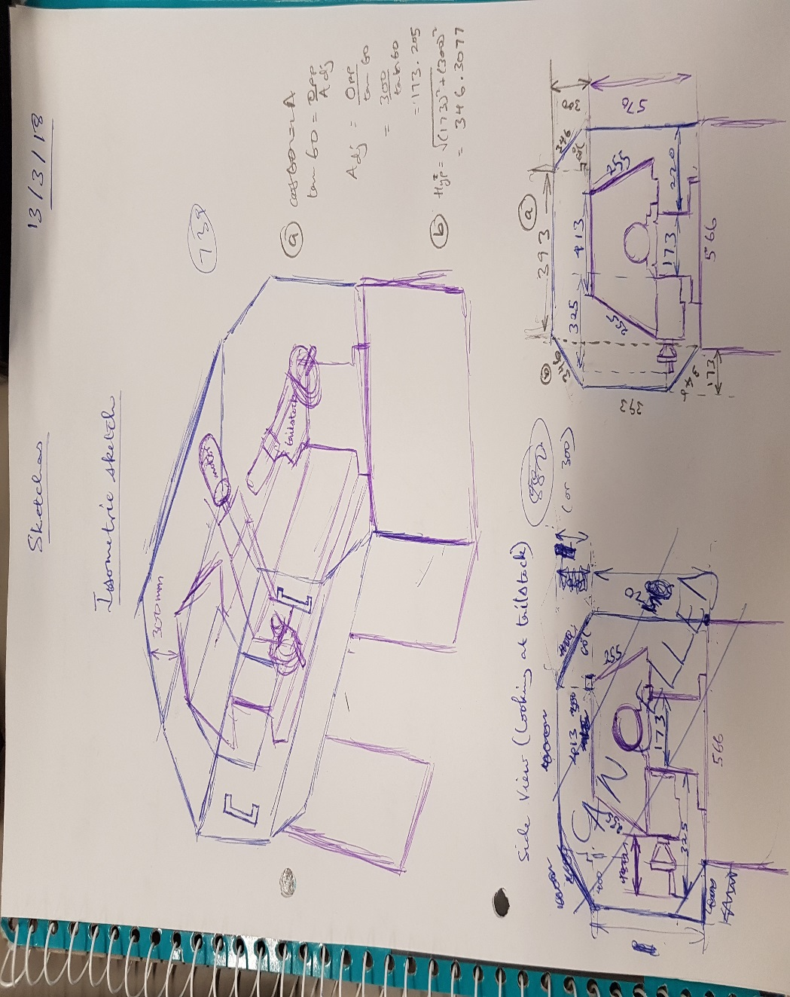

Changes were made to the initial design in order to change the position of the hinge to make the cover easier to open and also to improve the appearance of the cover. The cover was to be constructed out of 1.6mm Zyncalune and the window was to be made out of 4mm Polycarbonate. Considering the above, different parts of the cover were designed and modelled on computer. Drawings of some of the modelled parts have been generated as seen on the next page of this report. Calculations have also been made to select suitable pneumatic gas struts for the operation of the cover. The gas struts are required to correspond with the approximate load that the will bear.

Back plate

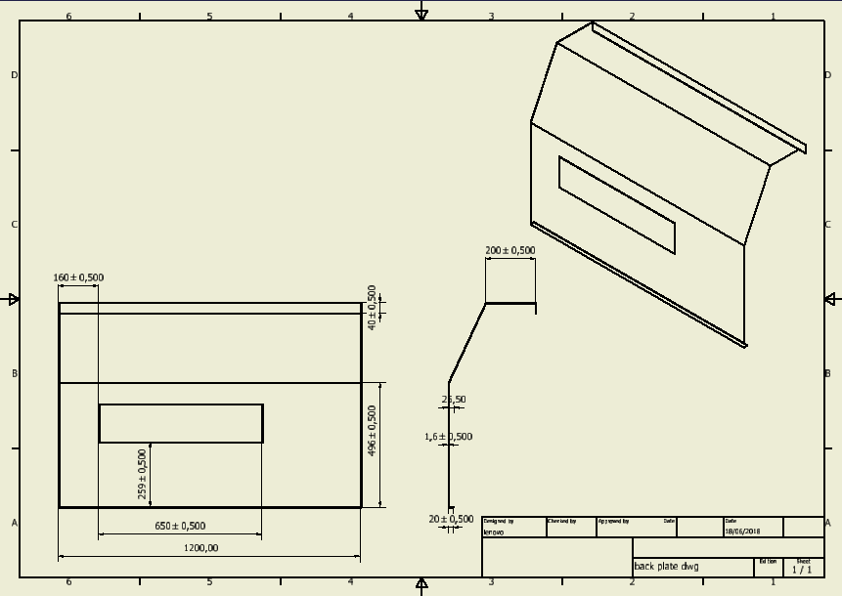

Front

